**BAHRIA UNIVERSITY,**

**(Karachi Campus)**

# Department of Software Engineering

**Assignment#01 – Fall 2020**

COURSE TITLE: **Data Communication & Networking** COURSE CODE: **CEN-222**

Class:  **BSE 5A/B** Shift: **Morning**

Course Instructor: **ENGR. MAHAWISH** Submission 29th Oct 2020 Date: 22 Oct 2020 Max. Marks: **05 Points**

**Student Name: Muhammad Arbab Anjum Registration #: 57226**

## Question_01 [CLO 3]

In the illustrated network, select only one communication path among the two possible paths between **nodes A and B**, then calculate the total delay required for a packet of size 512 KBytes to be sent from A to B. Also mention the selected path name in your answer sheet.

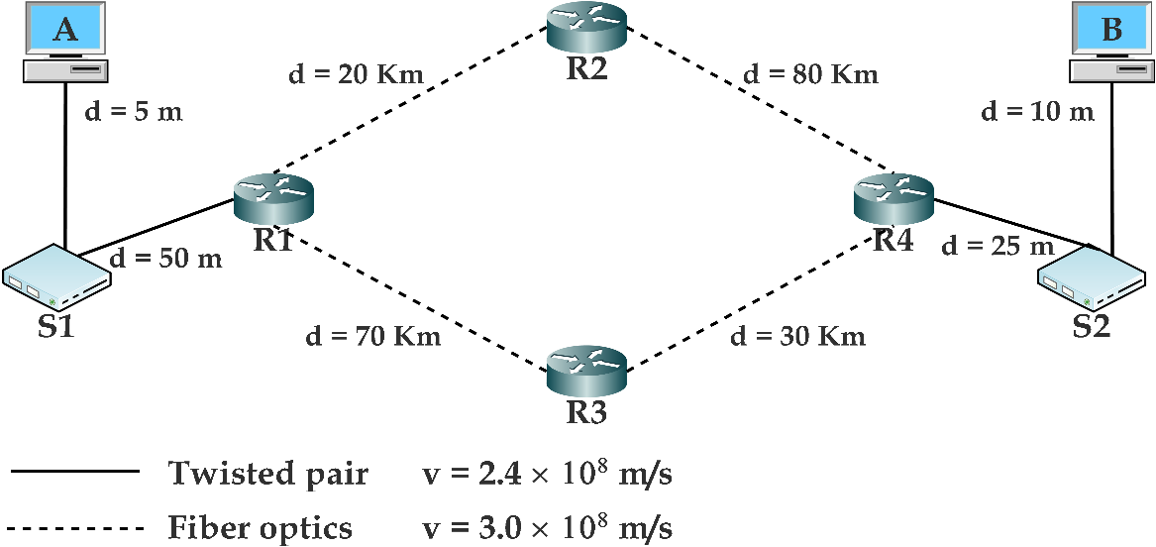

1. Transmission rate between (A, S1) (S1, R1) (B, S2) (S2, R4) is the same, which is 100 Mbps.
2. Transmission rate between all the routers is the same, which is 10 Gbps.
3. Processing delays are negligible and no delays are assumed at the switches.
4. Average queuing delays at each router are shown in table below:

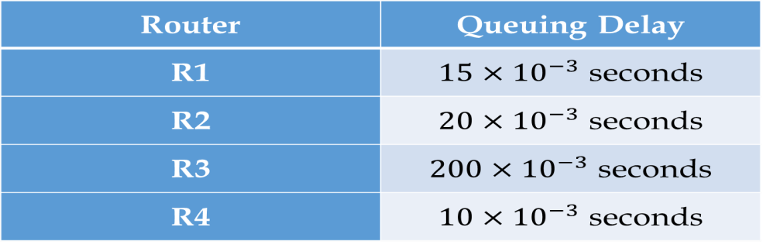

**Latency:**

The time it takes for a message to completely arrive at destination from the time the first bit is sent out from the source.

**Latency: 𝑝𝑟𝑜𝑝𝑎𝑔𝑎𝑡𝑖𝑜𝑛 𝑡𝑖𝑚𝑒 + 𝑡𝑟𝑎𝑛𝑠𝑚𝑖𝑠𝑠𝑖𝑜𝑛 𝑡𝑖𝑚𝑒 + 𝑞𝑢𝑒𝑢𝑖𝑛𝑔 𝑡𝑖𝑚𝑒 + 𝑝𝑟𝑜𝑐𝑒𝑠𝑠𝑖𝑛𝑔 𝑡𝑖𝑚𝑒**

**Path Selected:**

A🡪S1🡪R1🡪R2🡪R4🡪S2🡪B

